JUNE 10, 2019

Link to article: https://www.kexp.org/read/2019/6/10/cults-ian-astbury-his-life-music/

The Cult's Ian Astbury on His Life in Music

JAKE UITTI
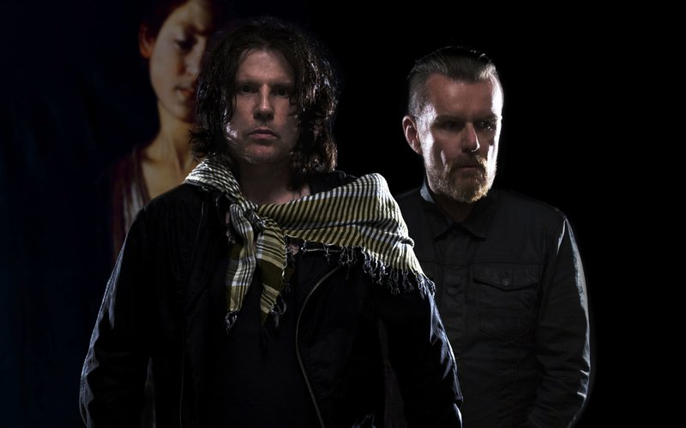PHOTO BY TIM CADIENTE
Ian Astbury speaks slowly, methodically. The front man for the historic British rock band The Cult, which plays Monday at The Moore Theatre, is thoughtful when he recounts his early introduction to music. For the Liverpool-born artist, the Beatles played a big role in his beginnings as a songwriter, but then his horizons expanded as a result of his exposure to David Bowie, Iggy Pop and Lou Reed. The Cult, which has significant collaborative connections with bands like Metallica, The Clash, Guns ‘N’ Roses and the Beastie Boys, has also been an influence to so many bands following their lead.
To preview the band’s upcoming Emerald City performance, we asked Astbury about his chemistry with his band’s lead guitarist, Billy Duffy, how the group began working with producer, Rick Rubin, and much more.
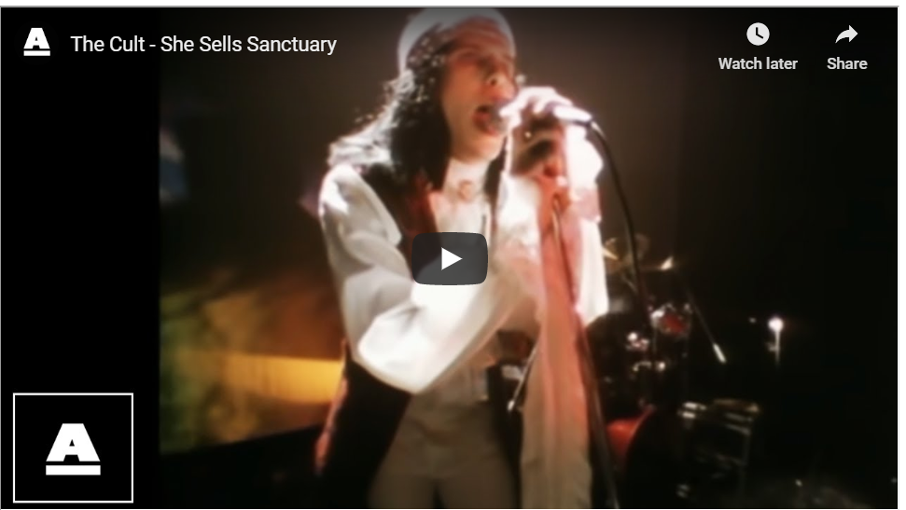

KEXP: What first drew you to music?
Ian Astbury: I grew up in Liverpool when The Beatles were coming up. On my dad’s side, I had three aunts who were all teenagers and on my mom’s side I had seven aunts who were all teenagers and they were all obsessed with music. So, I spent a lot of time being babysat by my aunts who played the contemporary music of the day, which was everything from The Beatles to the Stones. My mom and dad had a lot of music in the house. Everybody was into The Beatles, obviously. But my father was into things like old gospel spiritual stuff like Paul Robeson. This music was always in my home. My mom loved Johnny Mathis.
I was always around music. The culture at that time was incredibly immersive for music. So, I experienced that as a very young child through the 60s. But the real shift, to me, was probably - I saw The Magical Mystery Tour on TV when I was probably about, what, 5 or 6, and that was pretty mind-blowing even though it was in black-and-white. But it also really started for me with Bowie. Seeing Bowie on Top of the Pops doing “Star Man” and then buying “Life on Mars,” which was the very first single I bought at the age of 10. That just blew everything wide open.
I was voracious, I just had to consume as much music as possible. My parents bought me a cheap transistor radio when I was about 7 or 8, which had a single earplug. So, I used to listen to Radio Luxembourg, which was a very progressive radio station broadcast from Luxembourg into the U.K. They were playing stuff - I remember hearing “Riders on the Storm” because it was just so incredibly otherworldly. They were playing way more progressive music, so I was exposed to that. A lot of it, I didn’t know what I was listening to but I was so in love with it.
Then I moved to Canada when I was 11 and was all of a sudden - in the U.K. we had, like, Radio One, BBC One, TV One. It was really limited outlets for music. I had Radio Luxembourg, which I listened to every night in my bed. I had it under my pillow, I wasn’t supposed to have it. But when we went to Canada, there was FM radio, all the TV shows, Midnight Special, American Bandstand, Soul Train. It was way more culturally diverse and very early, like, 11 or 12, I was exposed to that. I was an avid watcher of American Bandstand and Soul Train on Saturday mornings. I used to try and copy the dance moves from Soul Train, you know? So, there’s a lot of information coming in in terms of music at a very early age.
You traveled a lot as a young person. How did that help shape your creativity?
I think having a counterpoint in the sense that growing up in the U.K., I had a Scottish mother and an English father. To North Americans that may sound like that’s the same but actually in the U.K. there are chasms between - cultural differences, nuances. So, that was the first real counterpoint, being in a home with a Scottish mother and an English father. That was profoundly impactful because I was experiencing two different cultures. A Celtic, Highland culture and the English working class culture, as well. Then when we went to Canada as an immigrant, then I was exposed to an incredibly diverse area. I came in with a wave of immigrants who were coming in from the West Indies, the Caribbean, from Italy, Portugal, Germany, the U.K., Pakistan, India. There was this wave, which is now the Canadian norm, an incredibly diverse multi-cultural society. I was immersed in that at a very early age along with all the music I was listening to, which was incredibly influential. By the time that I’d gone to Canada at 11, I’d already been to about eight or nine schools, or more, because we were always shifting between Glasgow and the Liverpool area. And Liverpool was pretty diverse because it was a port city. We were culturally diverse, as well. Of course, The Beatles made it an international phenomenon. It made it way more cosmopolitan. So, being exposed to that was pretty important.
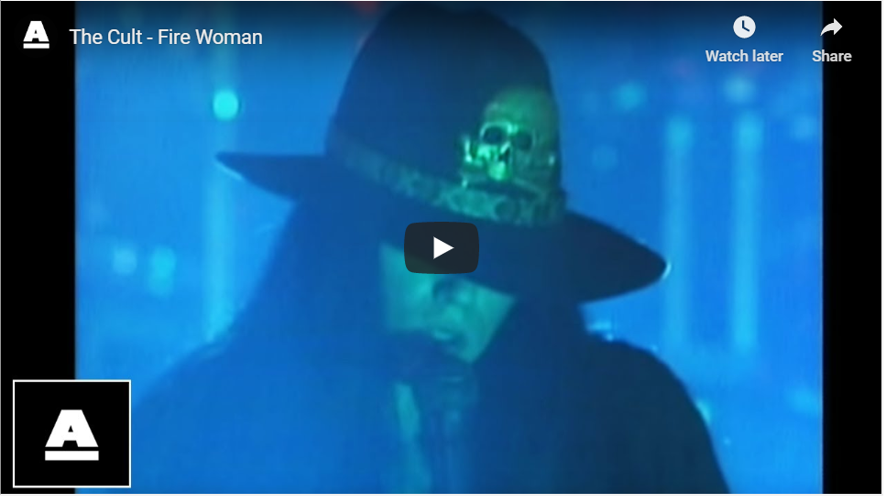
How did you develop your voice early on?
I guess just singing along with records, you know? I was always made to sing at family gatherings. I remember having to sing “Hey Jude.” One of my aunts thought it would be cute if I sang “Hey Jude” in front of the family. I was always into singing or mimicking the records I was hearing. Definitely Bowie for absolute sure.
Was there any musical study from a more academic sense?
No, not academic. There was never any academic - I was in various school choirs. You know, singing in the U.K. when you grow up, singing in assembly classes was always kind of like, that was something you were obliged to do. There would always be assemblies in school where everybody would have to sing and usually it was something, like, traditional hymns. School was quite formal. But I think academically - I took music in high school in Canada. Whereas learning to read music and learning about musical notation, I was always a dilettante. I wasn’t much of an academic. I was always, like, looking out the window. I was never fully engaged in classes - there were a few classes in which I was deeply immersed. I loved art, I loved history, I loved English literature. I really liked gym class because I was a good runner even though it was a volatile environment with boys vying for position. But perhaps some of the academic stuff stuck without me knowing it from choir and music class but I never pursued it consciously, you know?
What was your initial songwriting chemistry like with Billy Duffy?
The first thing that attracted me to Billy was the fact that he could actually play his instrument, which for post-punk generation was kind of a rare thing, to have mastery of an instrument. There were a lot of players but there were very few that had real mastery of their instrument. When I played in Southern Death Cult, everybody was learning their instrument. Buzz and Barry, the bass player and the guitar player, they were progressing quite quickly but I had a desire to go to the next level and wanted a musician who was far more accomplished. And Billy already had experience with, like, Morrissey, playing with Steven Morrissey and The Nose Bleeds and Studio Sweethearts, I think, was one of his first bands. So, he’d already had a wealth of experience of working with diverse artists and diverse influences.
In him I saw a foil to be able to express what I couldn’t express because I only picked up a guitar when I was about 16 or 17 and I just really learned basic chords. I was more interested in melodic passages and chords were a way of moving those melodies around but Billy was actually getting into play lead and scales and was far more accomplished. I was able to realize and actualize songs through Billy’s ability to play. He was a great player early on. He had his own style, his own sound. So, I think the chemistry was that we were always in an immersed environment whether we were recording or touring. We were living together for a while and we were going out to see a lot of bands play, a lot of shows. We bonded over Iggy Pop, David Bowie, those were some of the first shows we went to together, going to see the Birthday Party, The Clash, Gang of Four. It was this plethora of post-modern explosion of bands, this explosion.
So, we were immersed in the music scene in the U.K. and that just evolved through the next 12-to-13 years from when we first came together. I evolved as a songwriter, as well. I started to contribute more music to the band, which Billy would interpret and amend and add to. There was always a good musical dialogue between us, a good vocabulary, a good sense of understanding without actually having to state. Just being in proximity to each other was a huge part of the chemistry and that set a certain foundation for The Cult.
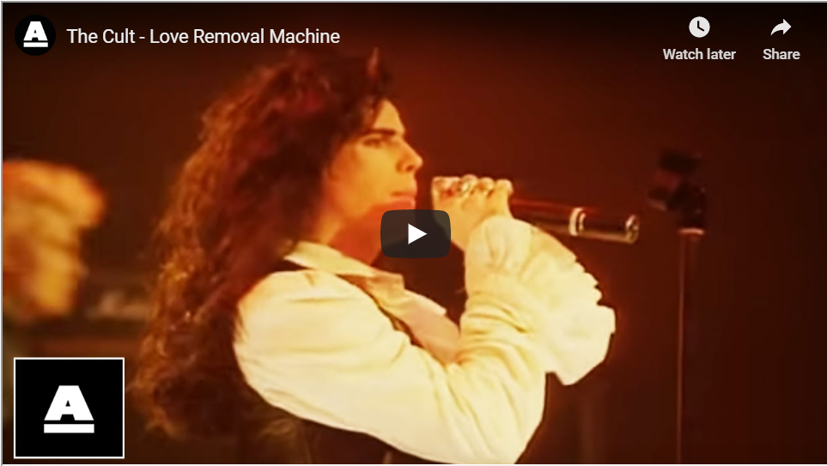
What memories first come to mind when you recall those 80s tours with bands like Guns ‘N’ Roses and Aerosmith?
Oh, forget those bands! My 5th show was opening for Chelsea at the Marquee in London. That was like going to the dark side of the moon. We were playing at one of the most hallowed venues in music of all time, where The Who recorded Maximum R&B. It was a huge moment for me as a young musician at the age of 19. Chelsea were incredibly established punk rock band who was part of the original punk rock explosion in the U.K. They were one of the archetypal bands. Then opening for The Clash, opening for Bauhaus. Playing festivals with the Birthday Party. That was probably way more profound. By the time we got to Guns ‘N’ Roses, we were veterans and they were opening up for us. It was just a continuation of what we’d been doing. At that point, we’d really developed into our own style and sound and we weren’t really influenced by artists as much. Perhaps hip-hop was a very important inclusion when we worked with Rick Rubin. If it wasn’t for The Beastie Boys, we wouldn’t have worked with Rick Rubin. We opened for Metallica in ’89, as well. We opened for Iggy Pop and David Bowie before we even got to Aerosmith. There was just so much information coming in.
What did you learn about yourself as an artist as you experienced more fame?
I wouldn’t say that I consciously was analyzing the evolution, my development or the creative process, or anything. I was just immersed in it. It was just my everyday experience. I was never outside it. It’s really interesting you ask this question because lots of journalists ask these existential questions because you guys are looking from the outside-in while we’re looking from the inside-out. It’s a completely different perspective or position. And in that sense, as you’re the center of it, of your small universe, you’re constantly receiving information, which you put through your filters and I never really - it’s almost impossible to objectify oneself externally in the same way that you may, you know? From that perspective, I don’t feel I was never really in an analytical mindset. I may question certain processes and choices but I was just so immersed in it. It was mostly instinctual.
Did you learn anything about your musicianship while playing with the Doors of the 21st Century?
Again, there wasn’t that kind of analytical experience. I was in a learning mode. I was receiving information and responding to it from Ray and Robby, two of the greatest musicians who have ever walked the earth. I was a student. I was there as much to facilitate their vision of what they wanted to do as I was being a student. I was sucking up every ounce of information. I had such a voracious desire to know what they knew. What they really knew was experience. They practiced their instruments. They cultivated themselves. They were erudite, they were intellectuals, they were empathic, they were my mentors, they were my friends.
The experience I had with The Doors, I think I’m still debriefing myself on that now. When people ask me about it, sometimes I go, “Yeah, shit, wow. I actually did 150 shows with Ray Manzarek and Robby Krieger!” I performed that body of work, which initially my intention was to serve the songs and serve the legacy and the relationship between that music and their audience. I knew I had a special responsibility to convey it in an authentic way and that just didn’t mean mimicking Jim Morrison’s nuanced vibratos and space and delivering vocal lines all the nuanced phonetics of it. It meant really understanding the spirit and the subtext of where these songs emanated from. In that way, I had to already have a lot of experiences I could draw from. They were helping me refine myself as a performer, being exposed to Ray and Robby. In hindsight, yes, I learned an awful lot from those guys and I’m still learning from that experience.
You mentioned The Beastie Boys earlier. How did they influence your career?
I remember hearing “Cookie Puss” in a club in Toronto in, like, ’85. And I went to the DJ and I said, “What is this?” And he went, “It’s by The Beastie Boys.” I had to know everything about them. When I found out they were being produced by Rick Rubin, I thought, he’s got to produce us because that is the sound. Stripped back, rhythmically driven, direct. We had to get that sound. So, we went and pursued Rick Rubin. We met him in ’86 and I want to say he was in an NYU dorm room but that may be a projection of time. But I’m pretty sure we were. I remember we sat in a very small room and he put on a TV. He had a VHS and he put on Blue Cheer and said, “What do you think of this?” We were like, “Wow, it’s really raw, it’s really primal.” And Rick said, “I think you need a bit more of this in your music.”
We were young guys, like, 25 at the time. And we were both, like, “This is so exciting!” It wasn’t as nuanced as the English producers who were making these elaborate pop records, layered and textured and what have you. This was way primal and direct and completely reflected our lifestyle at that time. So, that was the link between the Beastie Boys and The Cult. Then, if you look at the MTV New Year’s party in 1986 going into ’87, you’ll see me on stage with them performing “No Sleep to Brooklyn.” I was part of the posse on stage. We really immersed ourselves in that world, the Def Jam world. There were such incredible things in New York at that time and the conduit was the Beastie Boys. Then, later, things like the Tibetan Freedom Concert, which we played with Adam [Yauch]. I wouldn’t say it was an intimate relationship but it was certainly a parallel trajectory in some ways.
What do you still love about playing music?
Playing live, there is certainly an adrenal experience. The physical experience of actually five guys all pushing in the same direction. That creates a certain chemistry. Certain frequencies and melodies and rhythms vibrate at a non-rational level, a more sensual level, and that is an incredibly visceral experience. I think that’s what keeps drawing me back to live performance. You drop out of an egocentric experience and you drop into an experience where you really - you have to know the emotional intelligence of the space you’re in. It’s a really profound place to be and then you see the effect, the connection and the communion with an audience. Especially if the audience is locked into what you’re doing and they already know or have an emotional connection to some of the material that you’re performing, then that makes for a much more charged experience. You can put something over the top. There’s probably an addiction to it, as well, being in that space. It’s a high-energy experience and unless you’ve experienced it, it would be very hard to articulate, again, from the inside-out.
I’ve been in an audience and I’ve certainly watched performers and thought about or felt what would it be like to be in their shoes, what would their experience be of this? I am interested in that as a performer. I’ve asked many, many artists and I’ve had conversations with many artists about, “What’s it like to be you?” Because I was intrigued by that, I was really interested. I read biographies. I’m currently reading Brett Anderson’s biography, Coal Black Mornings, which I would recommend highly for anyone that’s interested in the psyche of a creative and how their background and how they evolved into the person they became. I really identify with a lot of things he says in his book. It’s a beautifully written, beautifully articulated, incredibly insightful work. And with that understand of that artist, you really appreciate the music at a much deeper level. There’s more of a personal connection to it, you know?
What are you looking forward to when you play Seattle Monday night?
We have a very special relationship with Seattle. Seattle was the first city in the United Stages in ’85 to - in fact may be the only city to program the Love album and “She Sells Sanctuary,” in particular, as a top-40 single. It was added as a top-40 single here. And that enabled us to come play the Paramount at the time and on that Love tour, we played there and that was one of the biggest shows of the tour and it was well attended. There were many artists who went on to form bands in Seattle that were present like Andrew Wood, Jeff Ament, all those guys were there. So, I’d like to think in some ways we’ve had this symbiotic relationship with Seattle. We were very close to Mother Love Bone and then later the early Pearl Jam.
In the early 90s we did a couple major festivals, one that we headlined in the U.K. which was called, “Cult in the Park,” with a very young, newly-formed band called Pearl Jam and Soundgarden as openers. L7 was on the bill, as well. I believe that bill moved to Holland where the headliner was Lou Reed. We ended up having to close the show because it was raining and Lou thought that everybody was going to leave before his set so they asked us politely if we’d acquiesce to headline, to close it. We were like, “Sure, if Lou Reed wants to take our slot, that would be an honor. Please take it! Anything to accommodate Lou!”
There was a lot of subtext about The Cult that people don’t really know. Is it necessary to experience The Cult? Not necessary but I think we’ve always been an outlier band. We’ve never really truly fit into any category and that wasn’t by any design or intention, that was purely by the fact that we just were always going with our instincts, you know? So, we ended up in different places. But right now we’re in a good moment. I’m really looking forward to the show in Seattle on Monday.
