POLLSTAR (3/26)
https://www.pollstar.com/article/what-the-f-is-happening-right-now-a-look-at-the-bizarre-world-of-frank-zappa-137615

‘What The F*** Is Happening Right Now’: A Look At ‘The Bizarre World Of Frank Zappa’
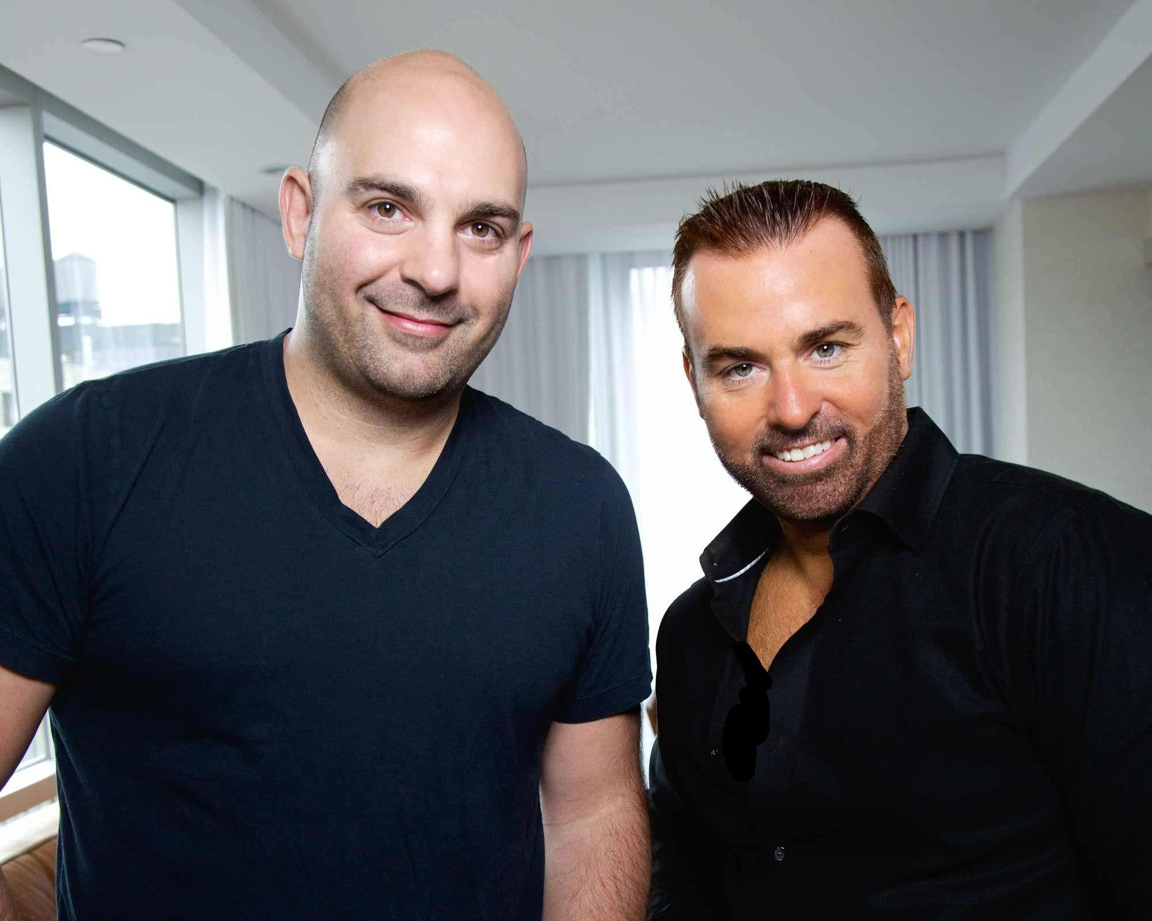Ahmet Zappa and Jeff Pezzuti-The masterminds behind The Bizarre World of Frank Zappa

"The Bizarre World Of Frank Zappa" hologram tour kicks off next month. While the show's technology is fascinating, the involvement of Zappa's son Ahmet Zappa makes it special. Pollstar met him at ILMC in London, alongside his business partner and friend Jeff Pezzuti, founder and CEO of Eyellusion, the company that produces the show, which includes the lifelike hologram of the late musician.
"It's emotional for me, obviously, because he looks like how I remember him as a four-year old. I stared in his face my entire life," Ahmet Zappa says. "Seeing the evolution of a static image into something that looks like its living and breathing is emotional. I can't underscore that enough."
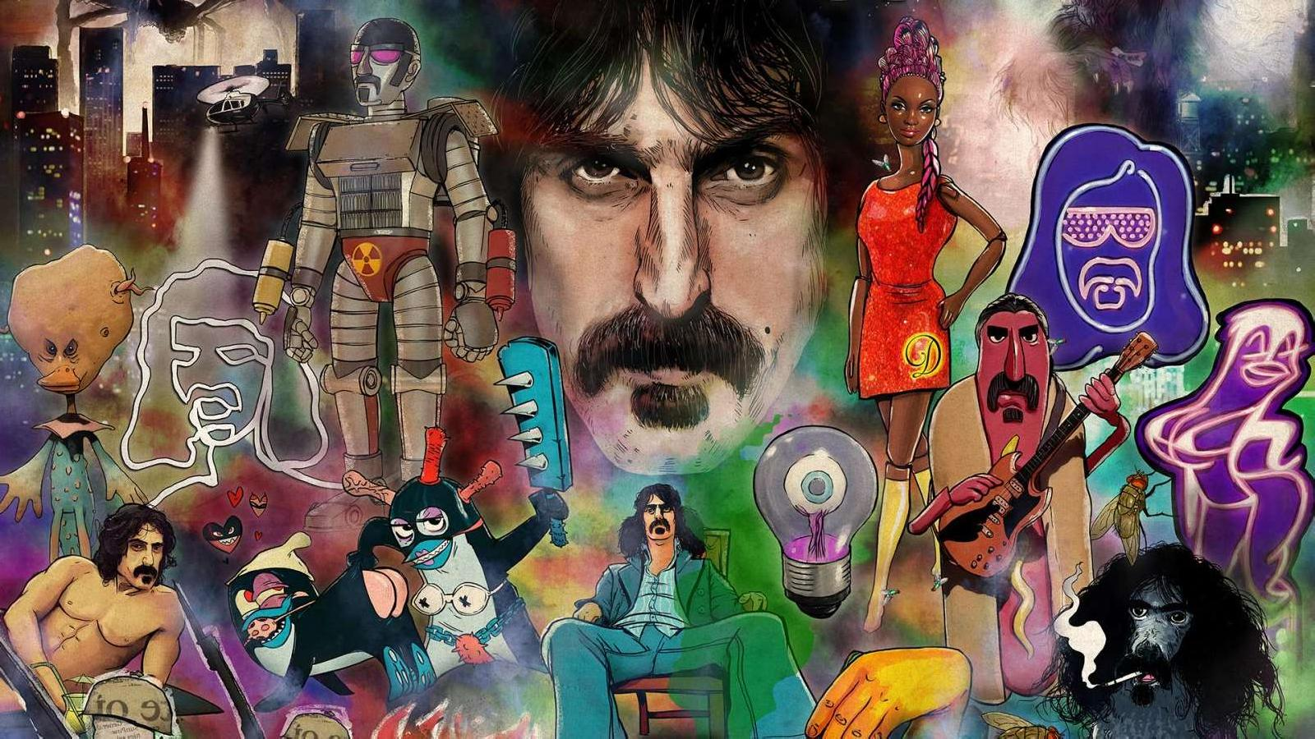The Bizarre World of Frank Zappa-The hologram show will tour the U.S. and UK in April and May

Frank Zappa wrote about the hologram business in his 1989 autobiography “The Real Frank Zappa Book.” Or, more precisely, he published the following business proposal he had once sent to his attorney:
“By using a modified version of the computer logic currently employed in the generation of 3D visuals for flight training simulators, in conjunction with an optical delivery system (yet to be designed), this device would make it possible to: (1) Generate free-standing 3D images, in any size (on your coffee table at home, or on a larger scale for theatrical use), 'folded out' from any two-dimensional source by precicting and synthesizing the missing third dimension.”
“As a kid, I was like 'what are you even talking about', but he walked me through what he was thinking,” Ahmet Zappa remembers. These father-son interactions inspired "The Bizarre World Of Frank Zappa.”
"We took some big swings with the show," Ahmet Zappa explains. "We have creative [content in there] I know my father would laugh at. We took into account his art style, the things that he was interested in, all the things he talked to me about growing up that inspired me."
Adds Ahmet Zappa: "Some of the early album artwork, the sort of collage art he would do, is very reminiscent of what Terry Gilliam used to do for 'Monty Python.' I know that stuff made him laugh. To [achieve] that aesthetic in one of Frank's songs during the show, we had to cut out 3,000 postcards."
Ahmet Zappa said he found a way to incorporate his father's love of cheap horror and monster movies – "the cheaper the better," according to his son – into the show, but that he didn’t want to spoil too much.
https://youtu.be/gzxa49fefq8
At one point in the show, a whole orchestra appears. "I won't tell you how, but it's one of many real magical moments. It's going to be this super psychedelic, mind-warping experience," Ahmet Zappa continues. "The show is magical surrealism. We're anthropomorphizing my father's music, we're visually telling those stories alongside the musicians.”
"The Bizarre World Of Frank Zappa" stands apart from other tribute or hologram shows because it features original band members including guitarists Ray White and Mike Keneally, bassist Scott Thunes, multi-instrumentalist Robert Martin, percussionist Ed Mann and drummer Joe "Vaultmeister" Travers.
When combined with Zappa's own guitar playing and vocals, isolated from old recordings, the audience will receive as authentic a Zappa experience as possible.
"The music in the show, I should point out, are performances that, unless you were in the rehearsal studio that particular day way back in 1974, no one's ever heard. They've been locked away in a vault," Ahmet Zappa says. "It's fan favorites, but performances they've never heard before. It'll feel new to fans. Plus, we have compositions no one has ever heard before that we're world-premiering at the show."
Eyellusion and Pezzuti have played a major role in realizing Ahmet Zappa's vision. “When the company started four years ago, I said, in five to seven years all the major touring acts that are making a ton of money – Rolling Stones, Paul McCartney, Fleetwood Mac – are going to retire," Pezzuti says. "The venues are going to have problems because of the overhead, they're not going to have anybody to go play them, and there's no Plan B. I said, 'This is the Plan B.'"
Pezzuti believes this form of technologically enhanced live entertainment will succeed because unlike VR or AR, it doesn't take away the communal experience. "The minute you but those googles on, it's you," he says. "You and me could be watching the same thing, but we're looking at it totally different, because we're isolated. We're not even in the same world. But who this, everybody's looking at the same stage, still laughing at the same thing. A concert is about the energy put out from what's going on on stage. And that's what we have maintained."
Pezzuti said the proof of concept came during one of the Dio hologram concerts, the first Eyellusion-produced hologram show: "He does a call and response during 'Heaven and Hell.' The first time that happened, when they sang back to the hologram, I literally said, 'Yes, yes, yes, it fucking works.' Boom."
According to Ahmet Zappa and Pezzuti, “The Bizarre World Of Frank Zappa” takes the possibilities of hologram technology to the next level, and not just for fans. "I really believe that you do not have to be a Zappa fan at all," Ahmet Zappa said. "If you want to have a wonderful, unique concertgoing experience, where you can feel like 'What the fuck is happening right now,' this is the show that I think sets a new benchmark for live music and what's visually possible.”
Ticket sales for the upcoming tour, Pollstar was told, "have been strong, especially given that sales have largely been driven by word of mouth. Two shows are close to sell outs in both the UK and the last show in Belgium."
Find the full list of "The Bizarre World Of Frank Zappa" dates below.
April 19, Port Chester, NY, Capitol Theater
April 20, Rochester, NY, Kodak Center Theater
April 22, Red Bank, NJ, Count Basie
April 24, Long Island, NY, Paramount Theatre
April 26, Boston, MA, Shubert
April 28 Albany, NY, The Palace Theatre
May 1, Wilkes Barre, PA, Kirby Center
May 2, Collingswood, NJ, Scottish Rite Auditorium
May 3, Baltimore, MD, The Modell Lyric
May 9, Edinburgh, UK, Playhouse
May 11, Gateshead, UK, Sage
May 12, Manchester, UK, Bridgewater Hall
May 13, Birmingham, UK, Symphony Hall
May 14, London, UK, The Palladium
May 16, Ostend, BE, Kurssal
May 17, Amsterdam, NE, Rai Theater

